Exercise: Android Storage
Document Number: |  | Issue Number:  Date:

TABLE OF CONTENTS
1 Exercise 1: Create a very simple Android application with SharedPreferences 2
1.1 Description 2
1.2 Create new Android application with SharedPreferences. 2
2 Exercise 2: Create new Android application with Internal Storage 12
2.1 Description 12
2.2 Create new Android application with Internal Storage 12
3 Exercise 3: Create new Android application with External Storage 20
3.1 Description 20
3.2 Create new Android application with External Storage 20
4 Exercise 3: Create new Android application with SQLite 28
4.1 Description 28
4.2 Create new Android application with SQLite 28

Exercise 1: Create a very simple Android application with SharedPreferences

Description
The purpose of this exercise is let student understand how to work with SharedPreferences. At the end of this exercise they can create a very simple application which will store and load SharedPreferences.

Create new Android application with SharedPreferences.
In Eclipse, go to File -> New - >Others
Choose Android -> Android Application Project.
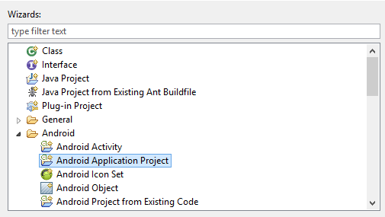
Name Application Name: SharedPreferenceExercise and press Next.
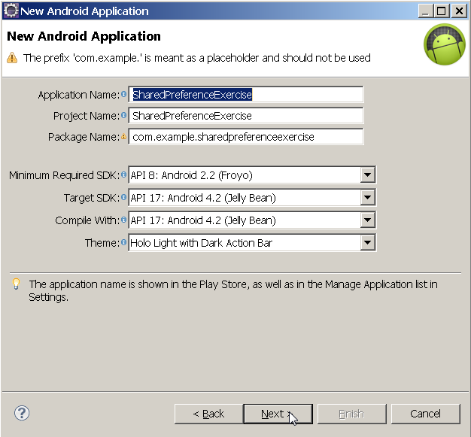
Continue to press Next until Finish is highlighted.
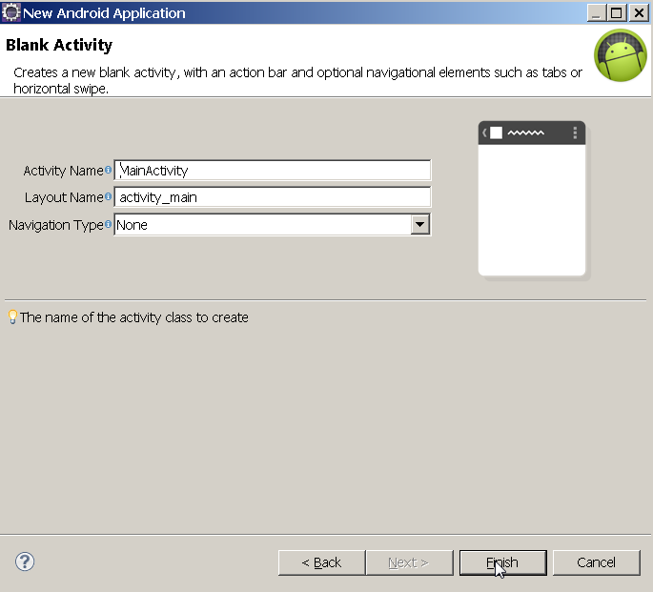
Click Finish.
In GUI designer, double click to let it expands full screen.
Build the GUI so it look like this:
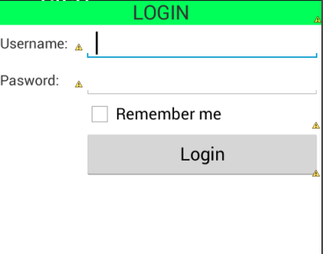
Create another Activity called LoginSucessActivity to display login success screen:
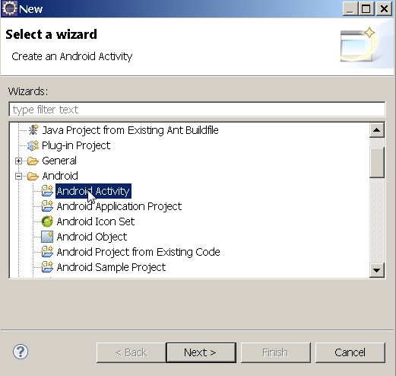
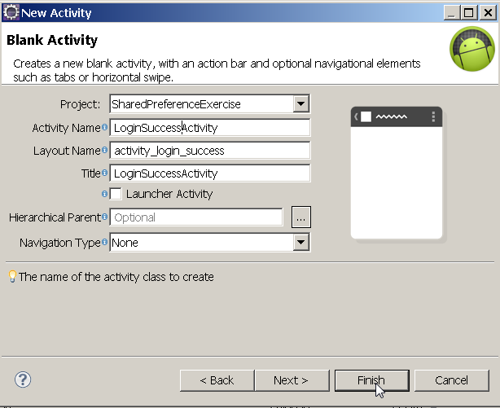

Click Finish. Open the GUI builder and design the GUI like this:
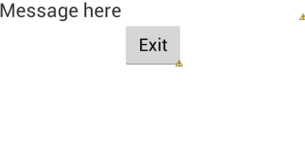
Open MainActivity source code and add listener to button Login:
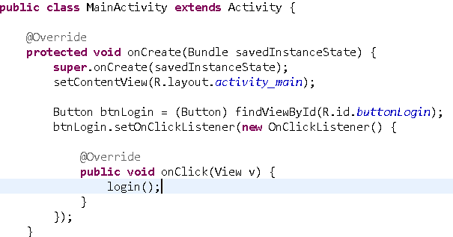
Add some properties to MainActivity:
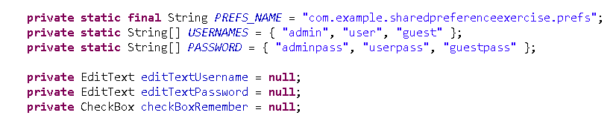
Add login() method to MainActivity:
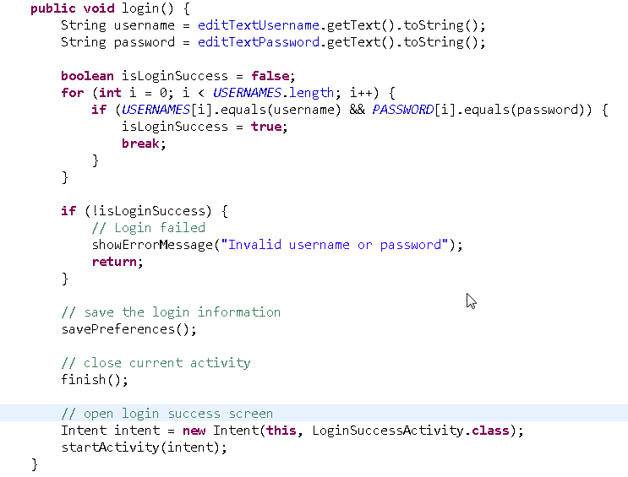
Add showErrorMessage() method to MainActivity:
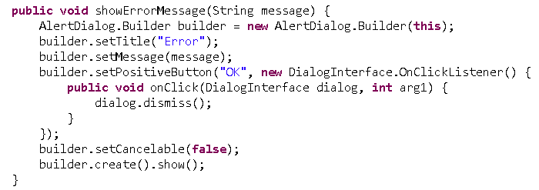
Add savePreferences() method to MainActivity:
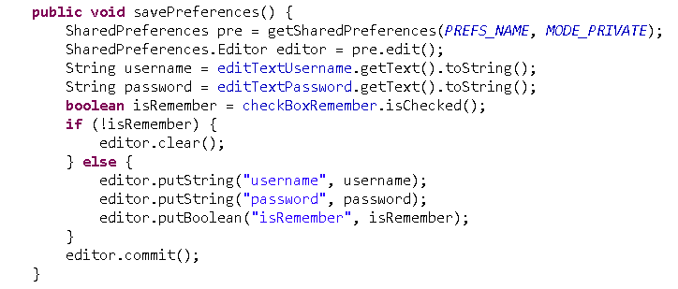
Add onResume() method to MainActivity:
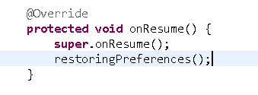
Add restorePreferences() method to MainActivity:
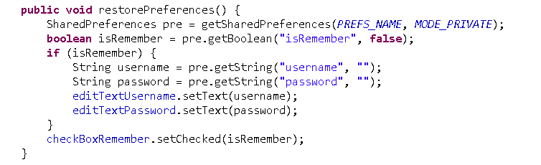
Open LoginSuccessActivity source code and add code to show login status.
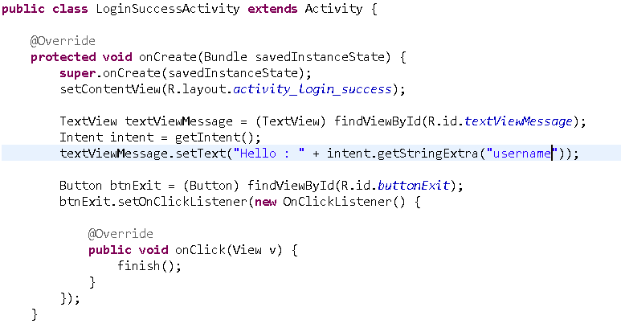
Right click on SharedPreferenceExercise, choose Run -> Android Application.
Switch on virtual machine, click Login button:
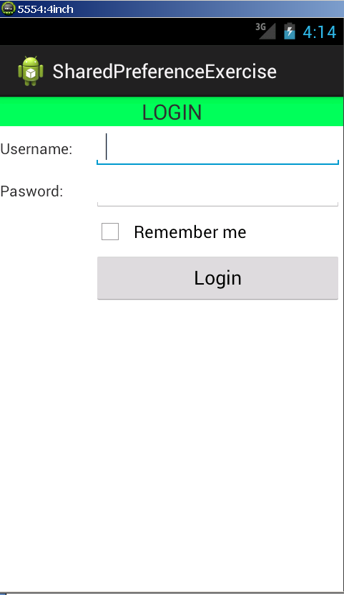
Error message will show:
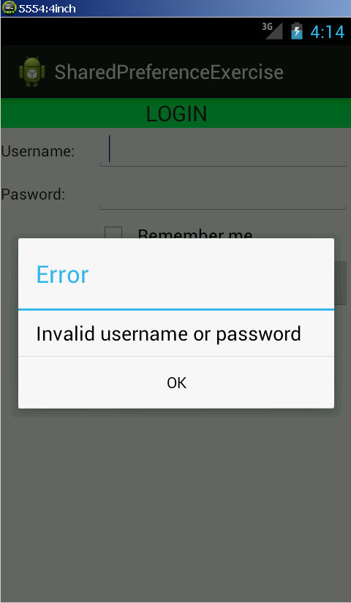
Now input valid username and password(“admin”/”adminpass”) but do not check “Remember me”:
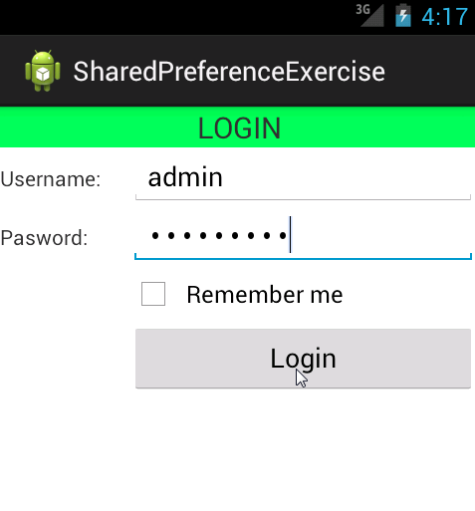
The login success screen will show, click Exit button:
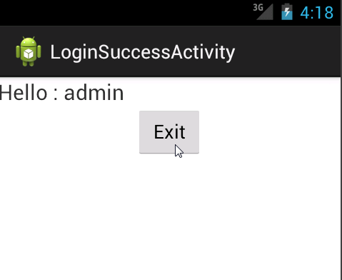
Find the application and open it again:
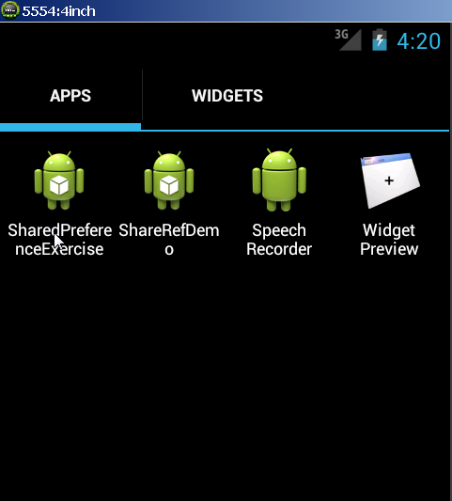
The data is clear:
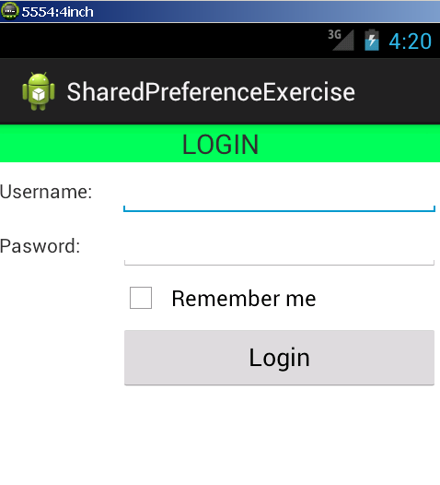
Now input valid username and password(“admin”/”adminpass”) and check “Remember me”:
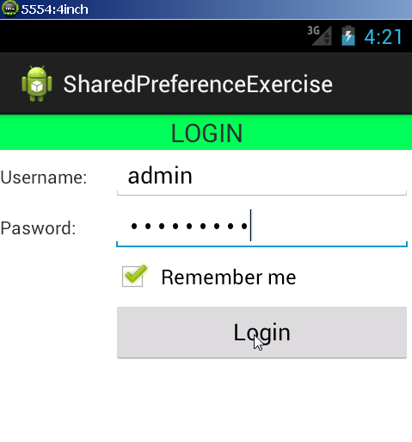
Login success screen will show, click Exit again:
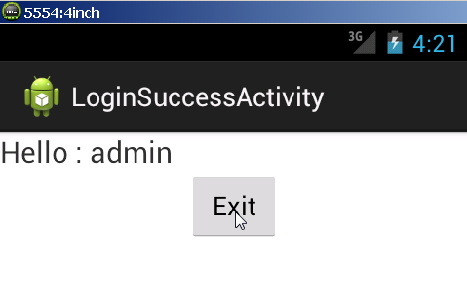
Find the application and open it again:
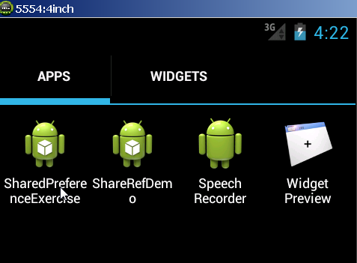
The login data is restored:
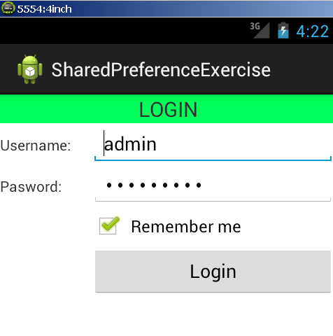
If you uses File Explorer in Eclipse to browse for the file, it is stored in data/data/ com.example.sharedpreferenceexercise/shared_prefs:
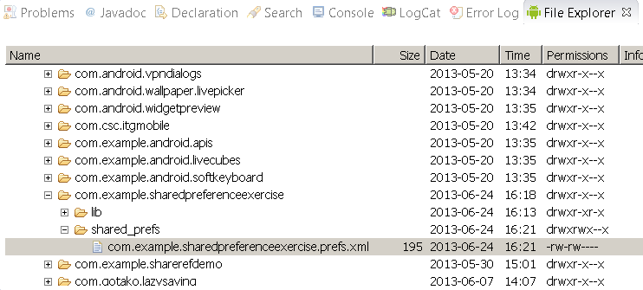
Congratulation! You have created your first working simple Android application using SharedPreferences.

Exercise 2: Create new Android application with Internal Storage

Description
The purpose of this exercise is let student understand how to work with Internal Storage. At the end of this exercise they can create a very simple application which will store and load Internal Storage.

Create new Android application with Internal Storage
Create new Android Application name InternalStorageExercise:
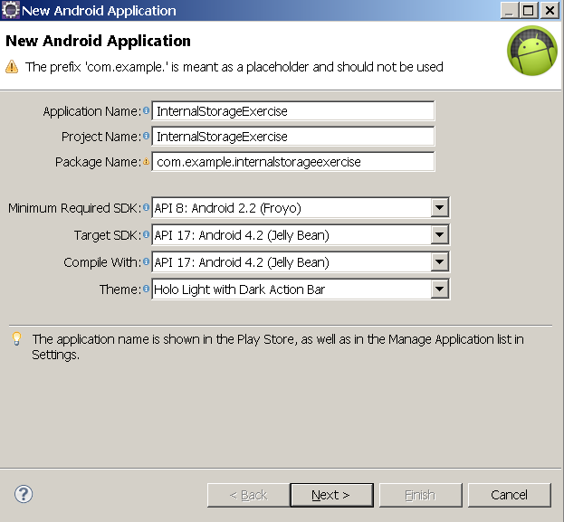
Create the GUI and Activity exactly the same as Exercise 1:
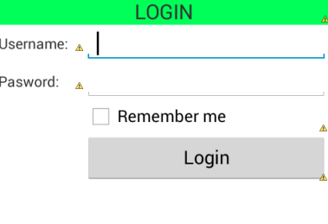

Create class LoginObject to store login information:
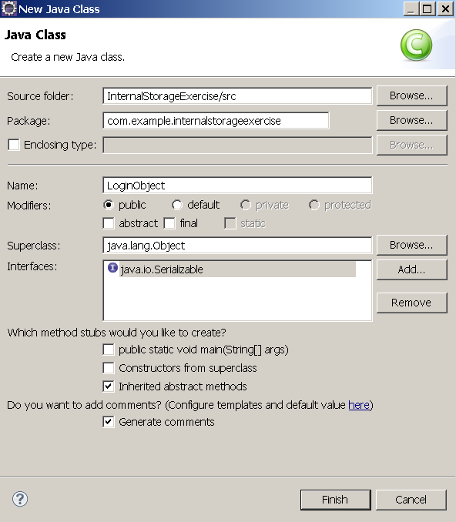
Click finish and change the code of the class to:
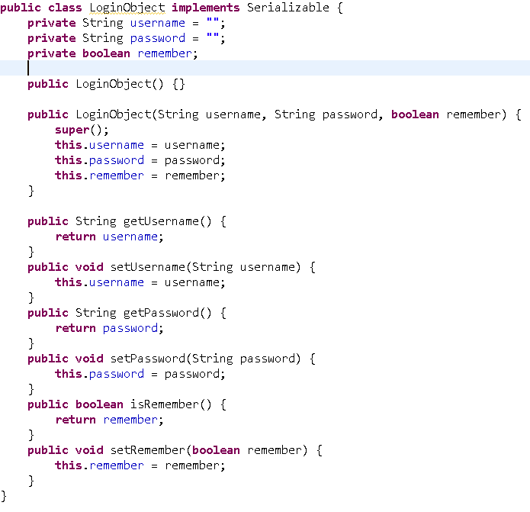
MainActivity source should be the same except the properties:
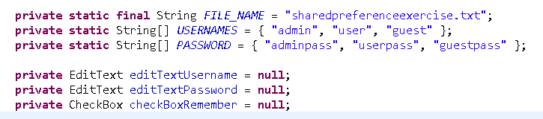
Change the content of method savePreferences() to use Internal Storage:
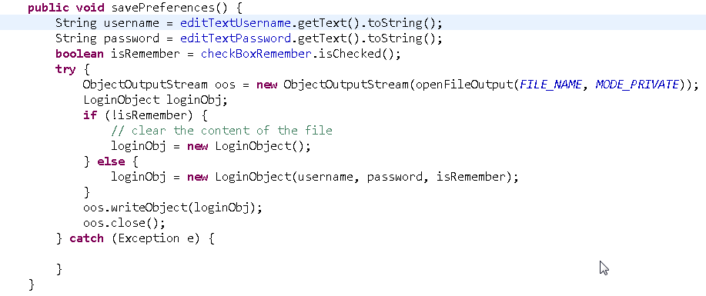
Change the content of method restorePreferences() to use Internal Storage:
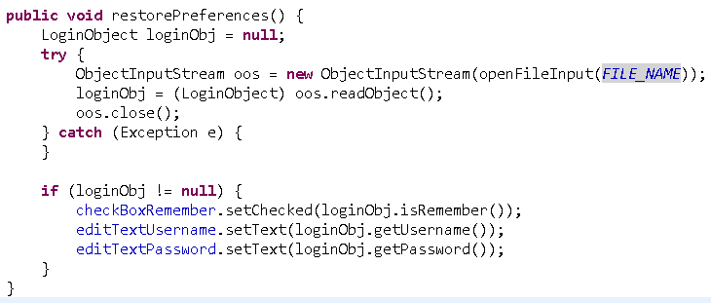
Right click on InternalStorageExercise, choose Run -> Android Application.
Switch on virtual machine, click Login button:
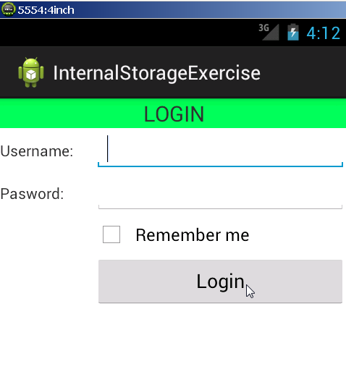
Error message will show:
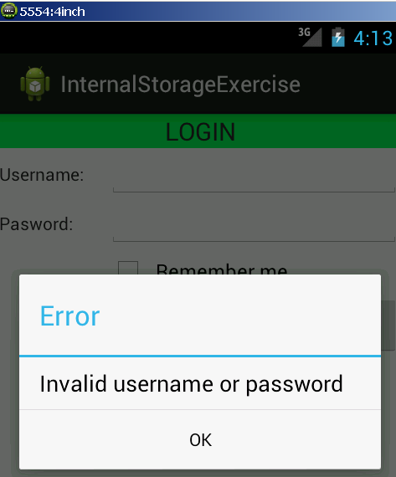
Now input valid username and password(“user”/”userpass”) but do not check “Remember me”:
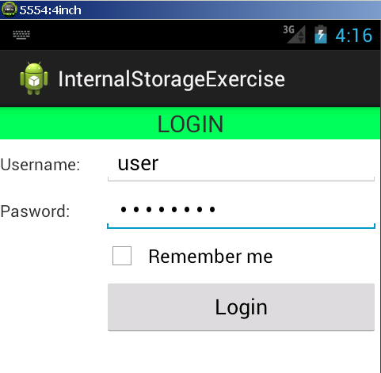
The login success screen will show, click Exit button:
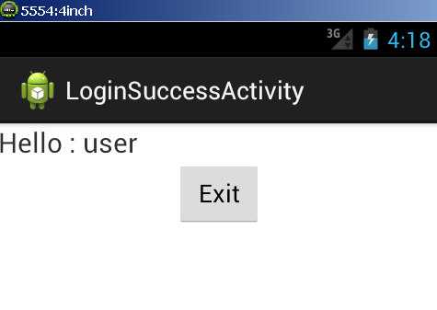
Find the application and open it again:
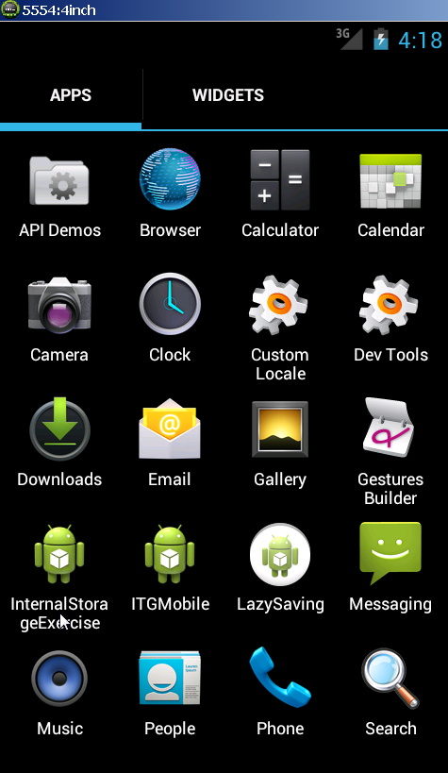
The data is clear:
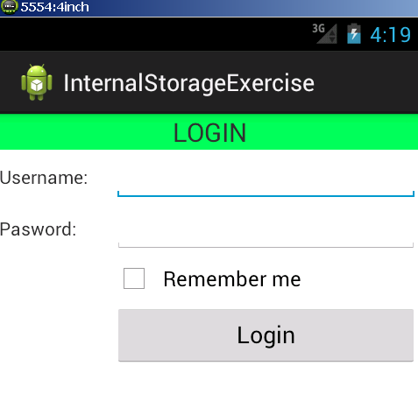
Now input valid username and password(“user”/”userpass”) and check “Remember me”:
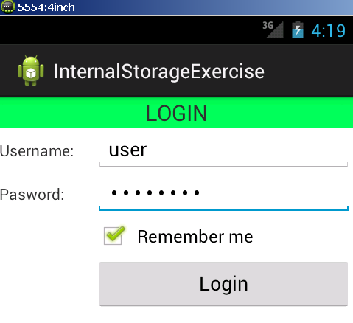
Login success screen will show, click Exit again:
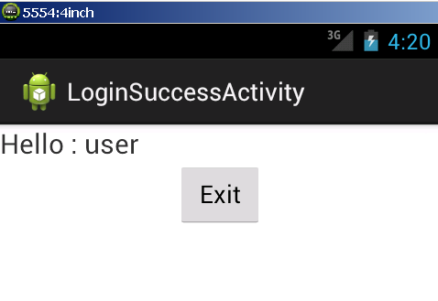
Find the application and open it again:
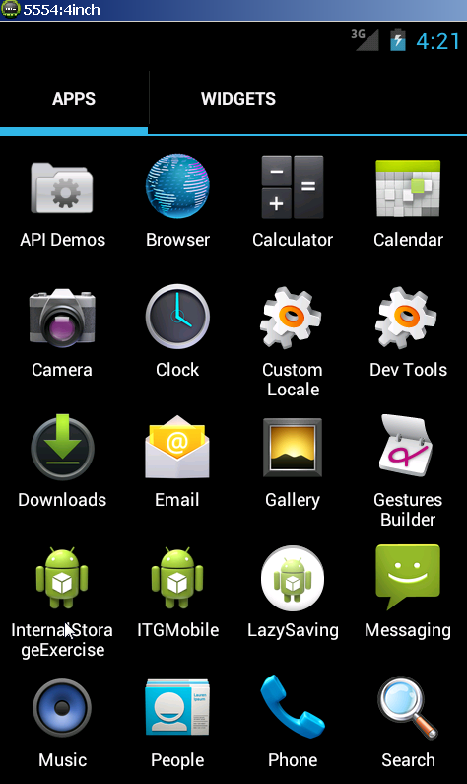
The login data is restored:
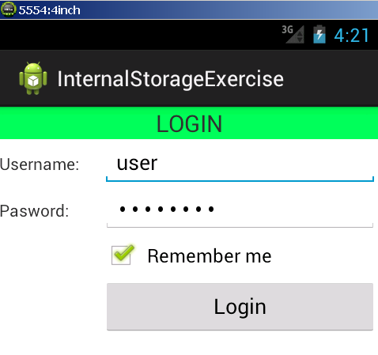
If you uses File Explorer in Eclipse to browse for the file, it is stored in data/data/ com.example.internalstorageexercise/files:
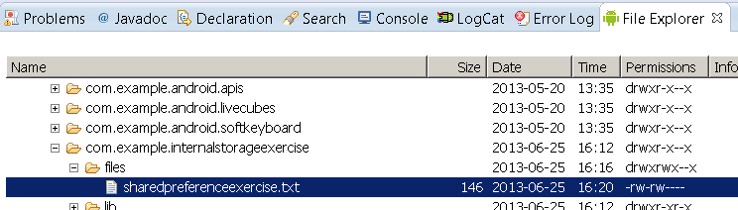
Congratulation! You have completed the second exercise.

Exercise 3: Create new Android application with External Storage

Description
The purpose of this exercise is let student understand how to work with External Storage. At the end of this exercise they can create a very simple application which will store and load External Storage.

Create new Android application with External Storage
Create new Android Application name 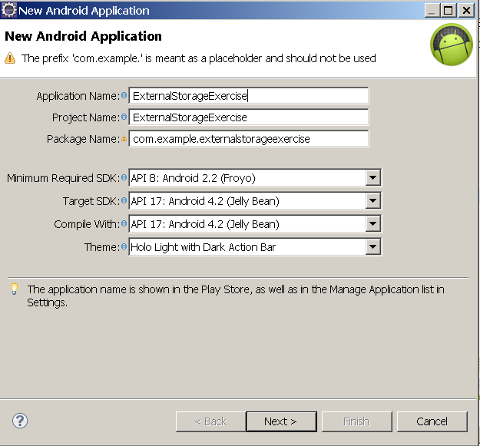:

Create the GUI and Activity exactly the same as Exercise 2:
Create class LoginObject same as Exercise 2 to store login information:
MainActivity source should be the same except the properties:
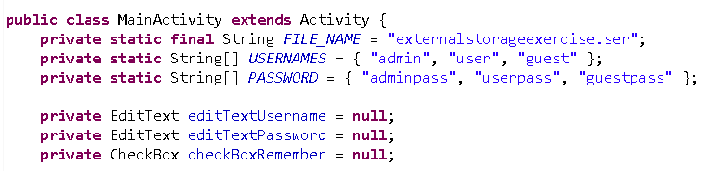
Create new class called ExternalStorageStatus to store the status of the external storage:
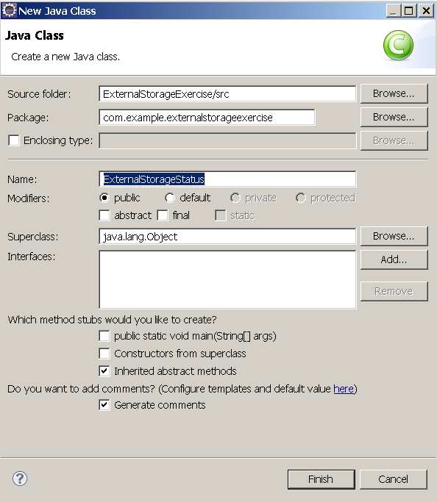
The content of the ExternalStorageStatus:
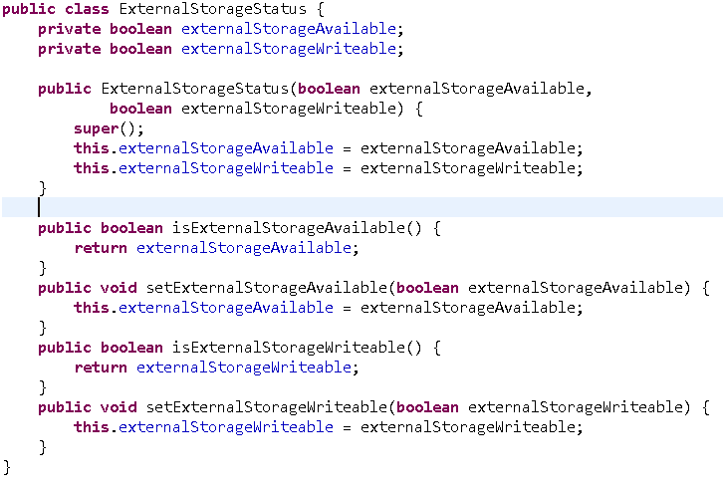
Add method check available of external storage to MainActivity:
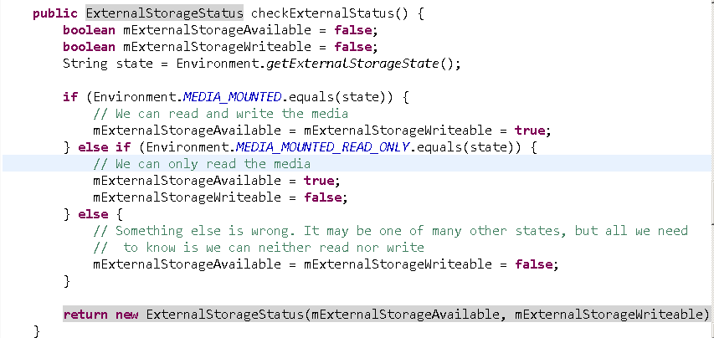
In login() method of MainActivity, change the code to:
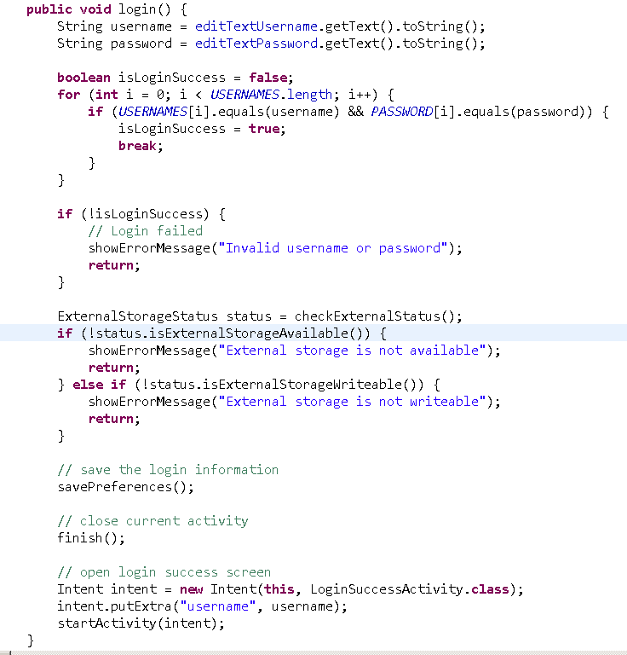
Change the content of method savePreferences() to use External Storage:
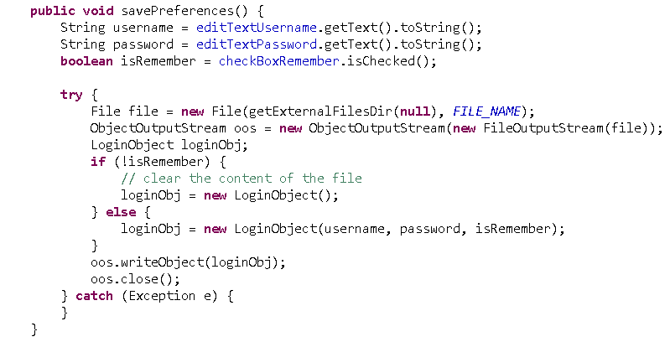
Change the content of method restorePreferences() to use Internal Storage:
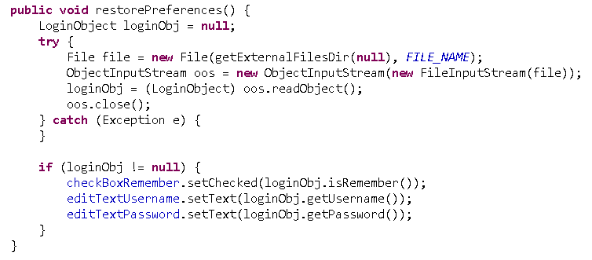
Right click on ExternalStorageExercise, choose Run -> Android Application.
The outcome should be exactly like Exercise 2.
Now change the API of the virtual device to 8:
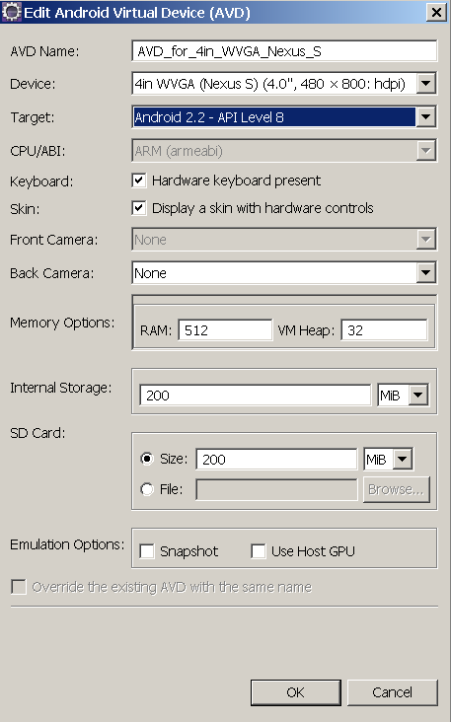
Start the device and go to Settings:
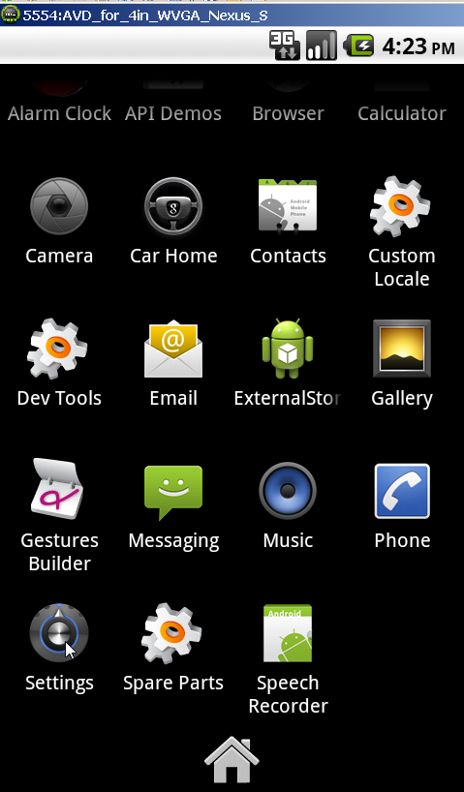
Go to SD card & phone storage:
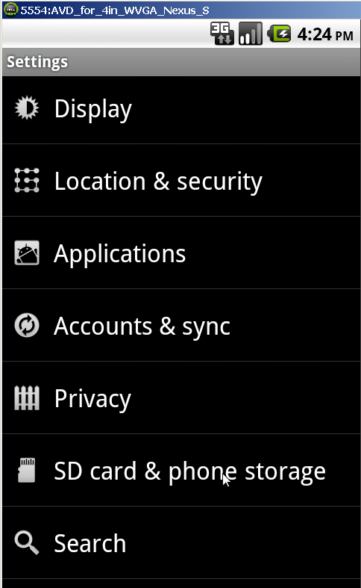
Choose unmount SD card:
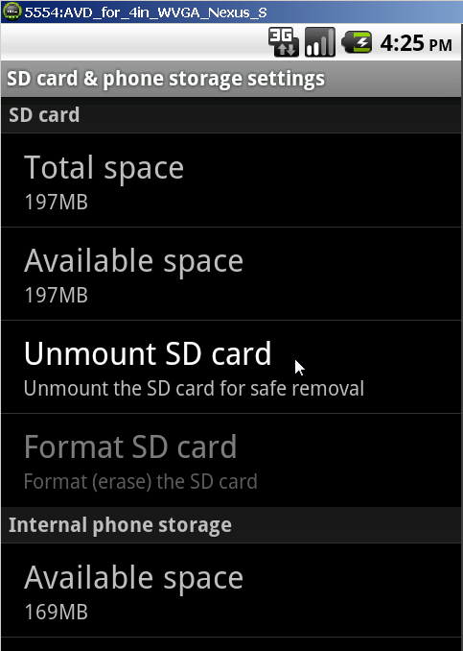
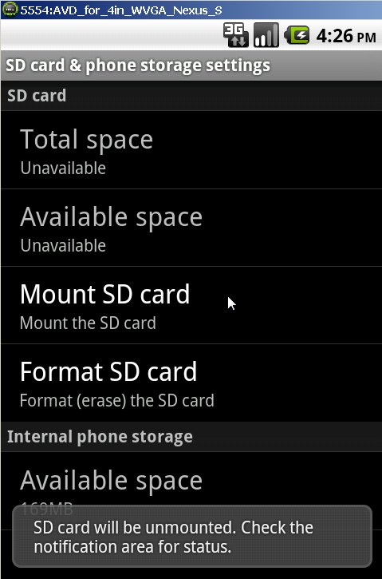
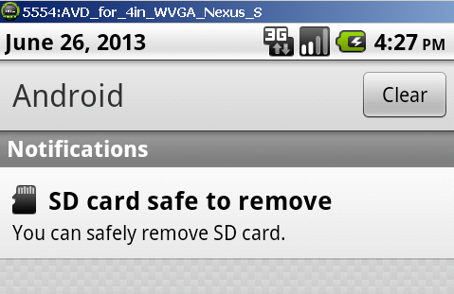
Find the application and open it again:
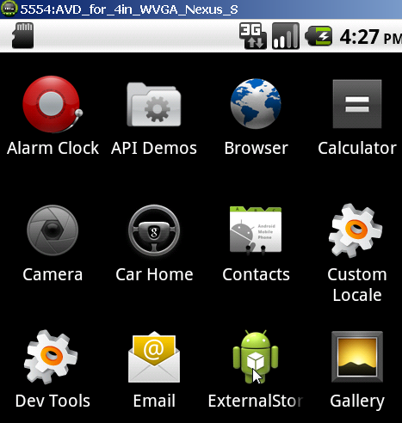

Now input valid username and password(“user”/”userpass”), check “Remember me” and click Login:
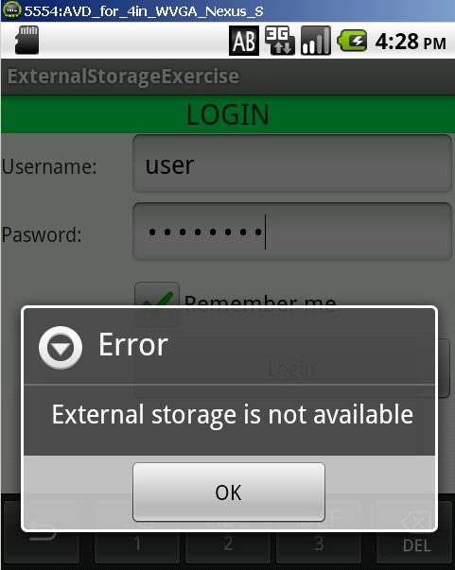
Congratulation! You have finished the third exercise.

Exercise 3: Create new Android application with SQLite

Description
The purpose of this exercise is let student understand how to work with SQLite. At the end of this exercise they can create a very simple application which will store and load SQLite.

Create new Android application with SQLite
Create new Android Application name:
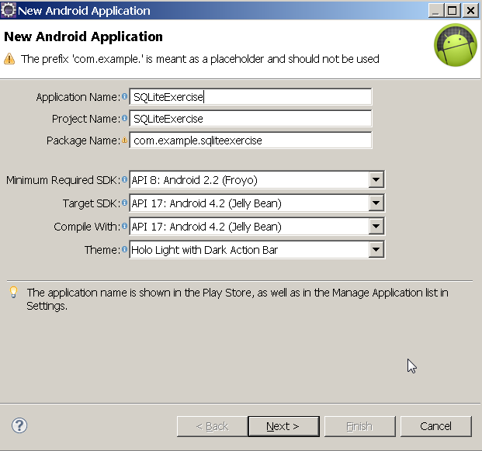
Continue to press Next until Finish is highlighted.
Click Finish.
In GUI designer, double click to let it expands full screen.
Build the GUI so it looks like this:
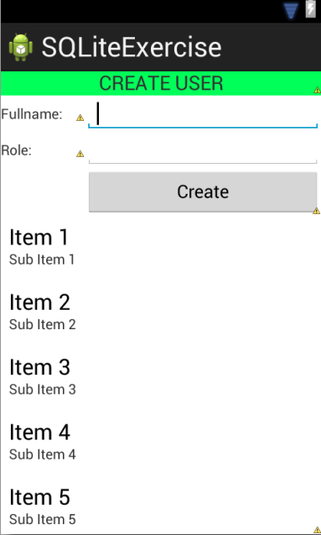
Create new class called DatabaseHelper to handle database:
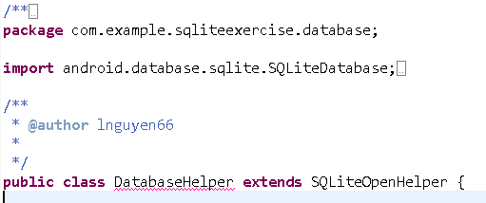
Add some properties to DatabaseHelper:
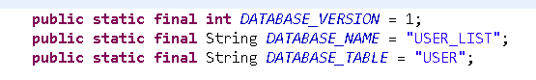
Add constructor to DatabaseHelper:
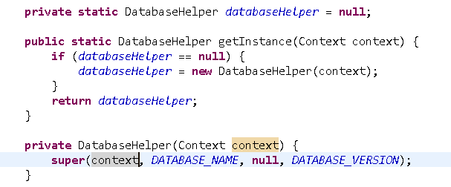
Add create database to onCreate() and onUpgrade() method of DatabaseHelper:
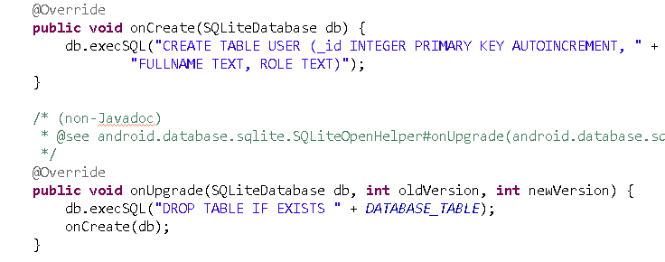
Add 2 methods createUser() and listUser() to DatabaseHelper:
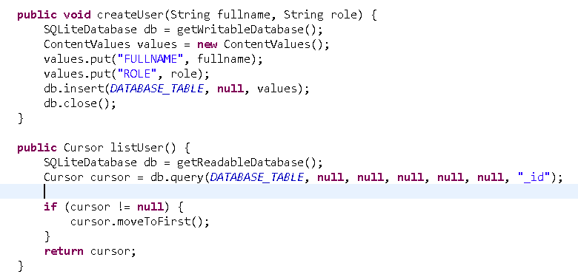
Open MainActivity source code and add listener to button Create:
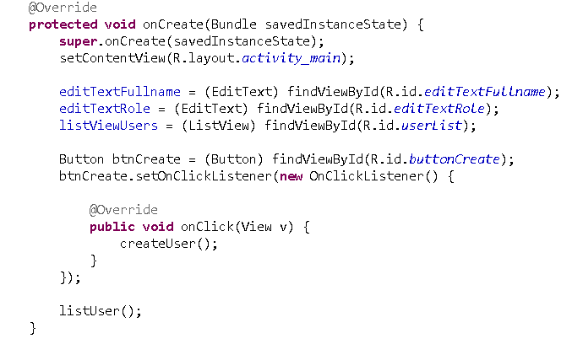
Add some properties to MainActivity:
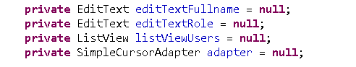
Add createUser() method to MainActivity:
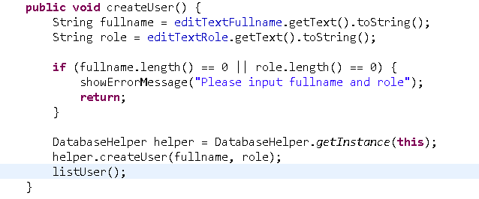
Add showErrorMessage() method to MainActivity:
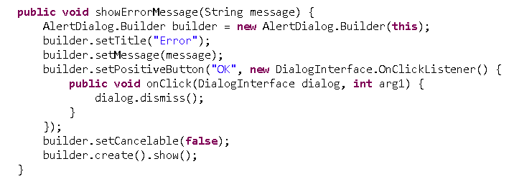
Add listUser() method to MainActivity:
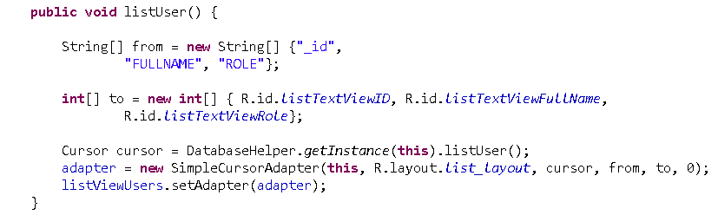
Right click on SQLiteExercise, choose Run -> Android Application.
Switch on virtual machine, click Create button:
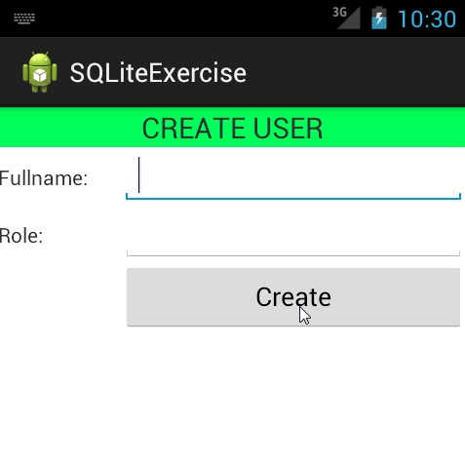
Error message will show:
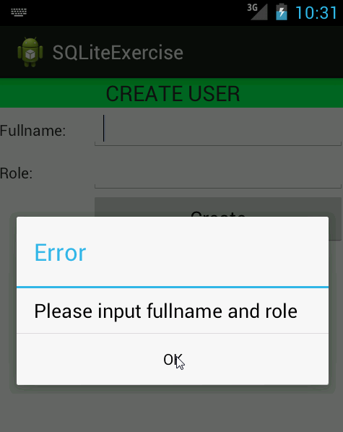
Now input valid full name and role:
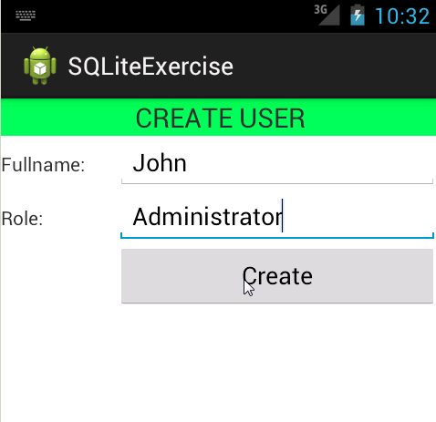
The user will be created and added to the list:
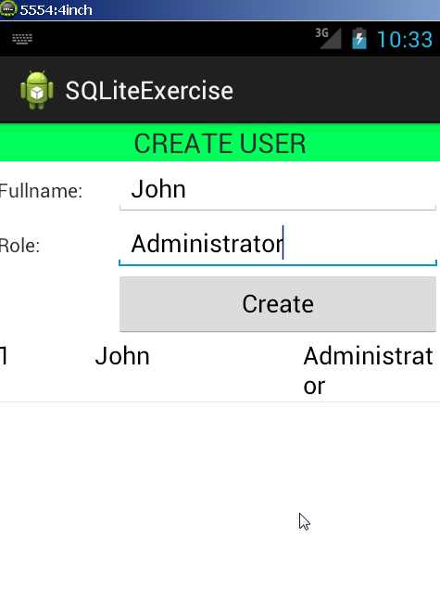

Congratulation! You have finished the forth exercise.

